Sammabine Admettre

Southern New Hampshire University

CS-250: Software Development Lifecycle

Professor: Judy Mason

June 22, 2024

**Reviewing and Looking Back: Putting Roles to Use**

I felt like I was on a Scrum team during this lesson. The team was transitioning from a waterfall to an agile strategy so that they could create an app for SNHU Travel. The project was worked on by a Product Owner, a Scrum Master, and a Development Team consisting of both Developers and Testers (Alami & Krancher, 2022). This article will discuss the Scrum and Agile approaches utilized for this project. For my research, I will draw conclusions regarding how these techniques benefited or harmed the final result (Alami & Krancher, 2022). Scrum's popularity stems from the fact that it improves software. Still, many firms do not observe quality benefits while using Scrum, and the current research does not reveal much about how Scrum might enhance software quality (Alami & Krancher, 2022).

**Product Owner**

In an Agile project, every team member is vital. This is a crucial feature since it allows the client and the Development Team to communicate directly with each other. As Product Owner, I am accountable for more than simply testing. I had to outline the actions that needed to be followed to finish the work. Some of the requirements were provided directly by the client, while the remainder were derived via a focus group of various end users (Todaro, 2019). I was in charge of developing and prioritizing user stories for the Product Backlog. Corporate partner’s objectives may conflict with one another, the product owner should investigate and be prepared (Todaro, 2019).

Scrum has the advantage of ranking the list at the end of each production sprint. It's organized according to how business is doing. Companies may alter their projects and areas of emphasis every week or month, depending on the duration of the sprint (Todaro, 2019). Then, the User Stories would instruct the Development Team on how to complete the project from beginning to end (Todaro, 2019).

**Scrum Tester**

When I assumed the role of Scrum Tester, I was tasked with supporting the Product Owner with Backlog creation and maintenance while ensuring total transparency at all levels within the Scrum team (Team, 2024). The Product Owner and the development team work together closely on Scrum to make the product (Team, 2024). The testing quadrants say that testers are in charge of both technology-facing tests that help the team and evaluate the product and business-facing tests that help the team and evaluate the product (Team, 2024).

**Development Team**

As a member of the Development Team and a Developer, I was allowed to structure my code anyway I saw fit, as long as I followed industry best practices (Trapani, 2018). As a Tester, it was my responsibility to collaborate with the rest of the team to develop test cases that would identify any flaws (Trapani, 2018). Iterative development relies heavily on the principle of testing early and often, making this process crucial (Trapani, 2018). That's why this section is so vital. The Scrum-Agile technique was founded on both of these perspectives, which were its fundamental components. These occupations increase the worth of the firm (Trapani, 2018).

**Review and Retrospective: Completing User Stories**

The Agile SDLC and Scrum methodologies are ideal for keeping project activities distinct. Misusing planning tools may be frightening. To ensure a successful rollout, break down difficult tasks into smaller, more manageable chunks. People who utilized the SNHU Travel project contributed to the creation of user stories (Understand Agile vs Scrum: Uncovering Differences & Similarities, 2019). User stories define the desired functionalities. Scrum software is delivered at the conclusion of each sprint, while agile software is often provided for feedback. Scrum is an Agile strategy that employs stages in which everyone works collaboratively (Understand Agile vs Scrum: Uncovering Differences & Similarities, 2019). Both offer minor builds of the project, although they are not identical. People that want speedy results should employ the stringent Scrum technique, which does not allow for many adjustments. User stories are brief, but they educate users and authors how to utilize and compose them. User stories often express the demand while distinguishing between value and purpose. People are at the heart of agile software development, and a user narrative focuses on the end users to achieve this goal (Understand Agile vs Scrum: Uncovering Differences & Similarities, 2019). This section thoroughly describes what the development team performed. When a team reads a user narrative, they understand what they need to accomplish, why they should do it, and how it will help (Understand Agile vs Scrum: Uncovering Differences & Similarities, 2019).

**Review and Retrospective: Handling Interruptions**

Agile refers to a way of doing things that is open to change because it is adaptable and flexible. In agile projects, there is usually some doubt. As it is neither a method nor a system, it is not. This is different from a technique or process, which is much more detailed and will tell you how to do the job. On the other hand, a skeleton is meant to be unfinished all the way through. For example, when the SNHU Travel project changed its focus to detox and health travel, we were able to use what we had already made and change the code to fit the new objective.

**Review and Retrospective: Communication**

Concerns were made about how the current code base would work with the changes that were wanted for the SNHU Travel project.Since I'm the tester, I understand that I may need to create additional test cases depending on the information you provide and deliver them to you. I feel that this discourse contributes to the creation of a cohesive place in which individuals may be open and collaborative.

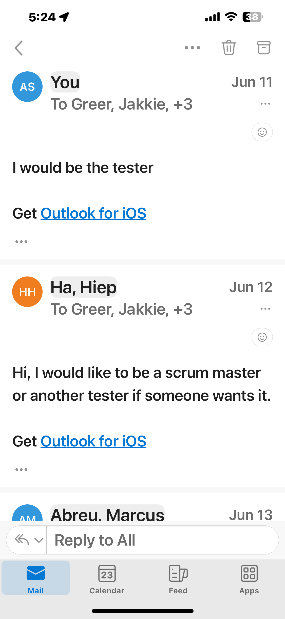

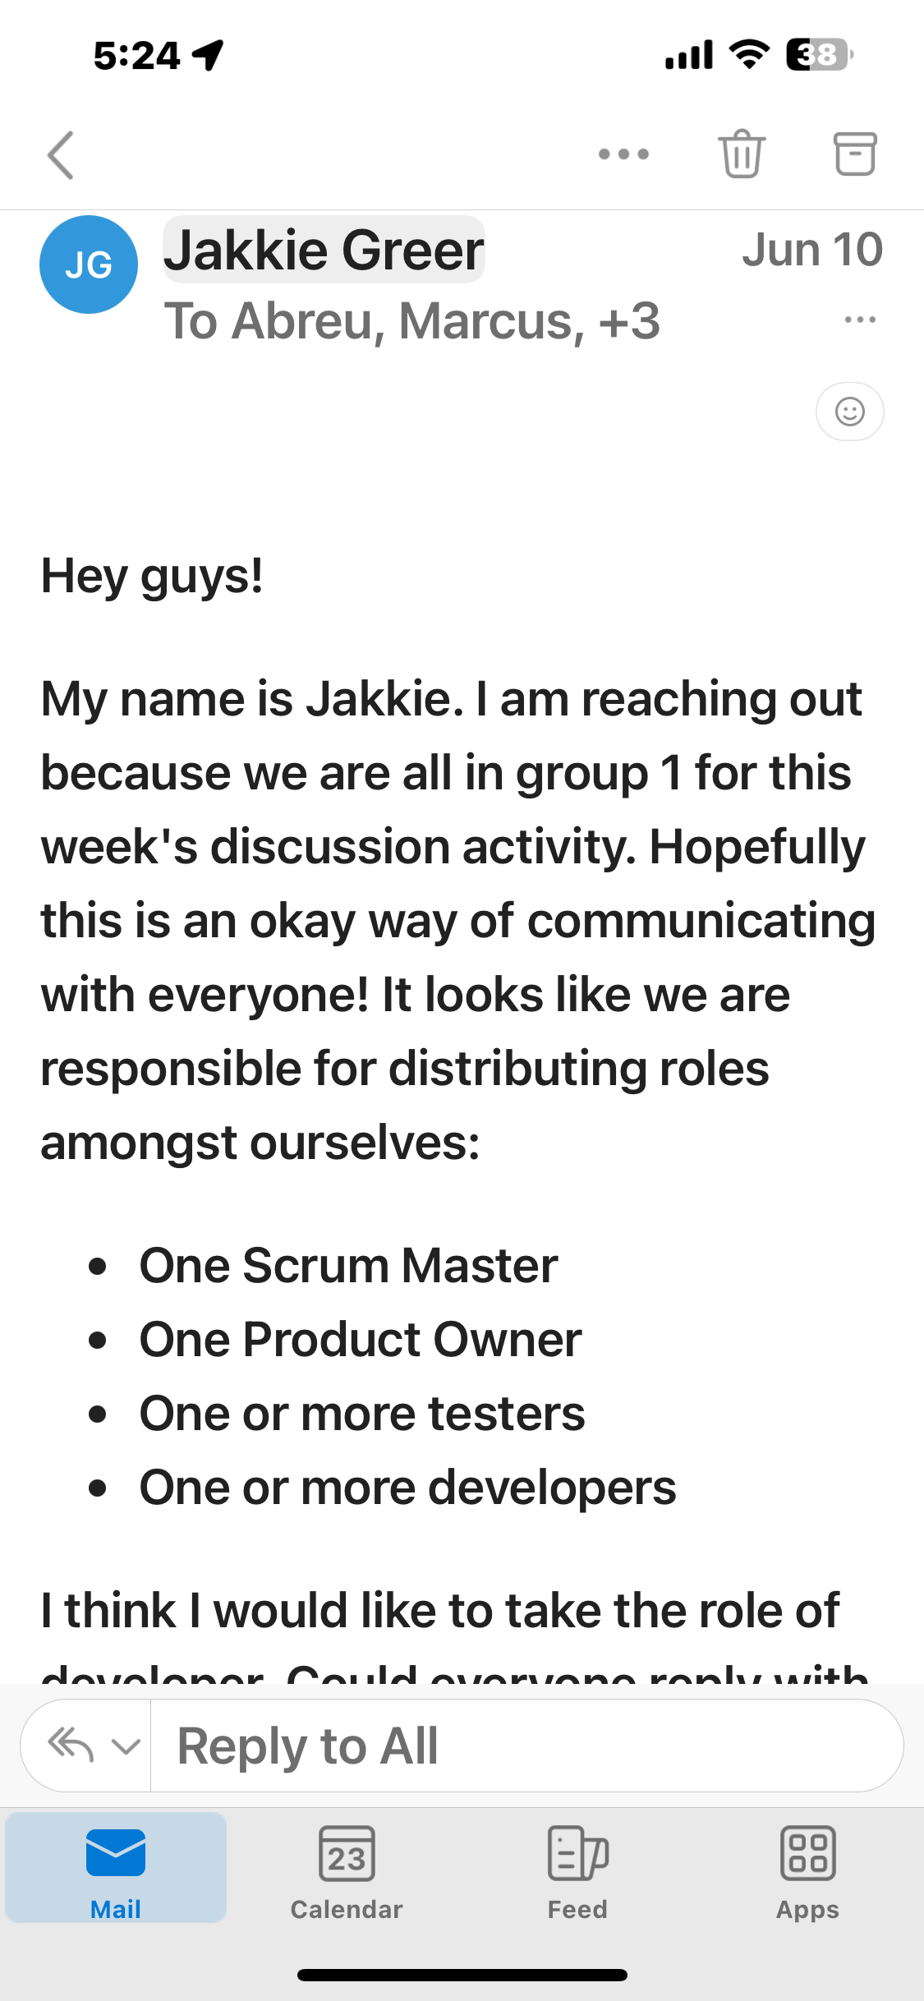

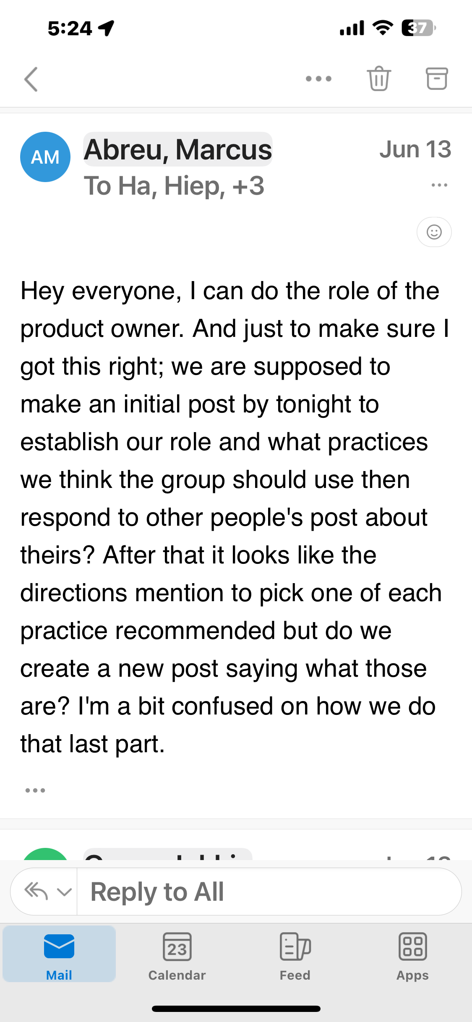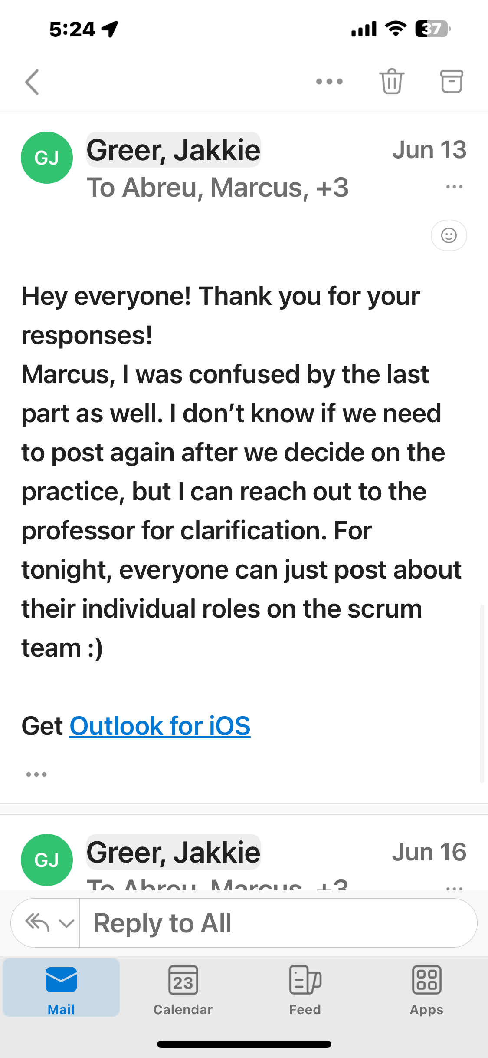

**Review and Retrospective: Evaluating Agile Process**

In my opinion, carrying out Agile on this work has both advantages and disadvantages. It was likewise difficult to predict what would occur with the SNHU Travel program. Without a mechanism to regulate the project's scope, it may swiftly deviate and cost more than expected. Scope creep is almost always unavoidable in Agile projects, as the client's requirements might alter at any moment.

The benefit of not being able to foresee what will happen is that it leads to improved product quality, partner input, and consumer satisfaction.Overall, I believe Agile was the greatest fit for the SNHU Travel project since it clarified things and offered us more flexibility. We also reduced the likelihood of missing a customer's critical request. Finally, a satisfactory product was provided, making both the Development Team and the customer delighted.

To summarize, Agile is more popular among project management teams. That being said, not all projects will be successful. Before committing to an Agile methodology, it is critical to have a fundamental grasp of what is required. When adopting Agile on a project, it may be beneficial to have access to a vital resource. In my perspective, the advantages of creating a high-quality product that provides value outweigh the unpredictability associated with Agile methodologies. The things that a firm offers that people value are critical to its existence and client loyalty.

Reference

Alami, A., & Krancher, O. (2022). How Scrum adds value to achieving software quality? *Empirical Software Engineering*, *27*(7). <https://doi.org/10.1007/s10664-022-10208-4>

Team, C. (2024, April 10). *Roles and Responsibilities in a High-Performing Software Testing Team*. CodiumAI. https://www.codium.ai/blog/roles-and-responsibilities-in-a-high-performing-software-testing-team/#:~:text=Software%20tester%20responsibilities%3A

Trapani, K. (2018, May 22). *What is Agile/Scrum*. CPrime; cPrime. https://www.cprime.com/resources/what-is-agile-what-is-scrum/

Todaro, D. (2019, October 23). *Scrum Product Owner Roles and Responsibilities*. Ascendle. <https://ascendle.com/ideas/scrum-product-owner-roles-and-responsibilities/#:~:text=One%20of%20the%20most%20important>

*Understand Agile vs Scrum: Uncovering Differences & Similarities*. (2019, September 26). Simplilearn.com. https://www.simplilearn.com/agile-vs-scrum-article#:~:text=In%20Agile%20methodology%2C%20software%20is